%% 2. MODULATION INDEX
mu = Am/Ac; fprintf('\n');
fprintf('====================================================\n');
% Load resistance = 50 ohms
R = 50;
% Carrier amplitude
% Message amplitude
Ac = 1;
Am = 1;
t = 0:1/Fs:T-1/Fs;

% Carrier and message parameters
fc = 100e3; % Carrier frequency = 100 kHz
fm = 10e3; % Message frequency = 10 kHz
% Sampling frequency = 1 MHz
% Simulation time = 10 ms
T = 0.01;
clc; clear; close all;

%% ============================================================
% CHARACTERISTICS STUDY OF SIDEBAND POWER AND FREQUENCIES IN AM
% USING MATLAB
% ============================================================
%% 1. INITIAL PARAMETERS Fs = 1e6;
====================================================
fprintf(' AM SIDEBAND POWER AND FREQUENCY STUDY\n');
AM SIDEBAND POWER AND FREQUENCY STUDY
fprintf('====================================================\n');
====================================================

fprintf('\nBasic | Parameters:\n');
Basic Parameters:
fprintf('Carrier | Frequency | = %.2f kHz\n',fc/1000);
Carrier Frequency | = 100.00 kHz
fprintf('Message | Frequency | = %.2f kHz\n',fm/1000);

Message Frequency = 10.00 kHz

fprintf('Carrier Amplitude | = | %.2f V\n',Ac);
Carrier Amplitude = 1.00 V
fprintf('Message Amplitude | = | %.2f V\n',Am);
Message Amplitude = 1.00 V
fprintf('Load Resistance | = | %.2f Ohm\n',R);
Load Resistance = 50.00 Ohm
fprintf('Modulation Index | = | %.2f\n',mu);
Modulation Index = 1.00

%% 3. MESSAGE SIGNAL

message = Am*cos(2*pi*fm*t);

%% 4. CARRIER SIGNAL

carrier = Ac*cos(2*pi*fc*t);

%% 5. AM SIGNAL

AM_signal = Ac*(1 + mu*cos(2*pi*fm*t)) ...
.* cos(2*pi*fc*t);

%% ============================================================
% 6. TIME DOMAIN PLOTS
% ============================================================

% Message signal figure;
plot(t*1000,message,'LineWidth',1.2);

xlabel('Time (ms)');
ylabel('Amplitude (V)'); title('Message Signal'); grid on;
xlim([0 1]);

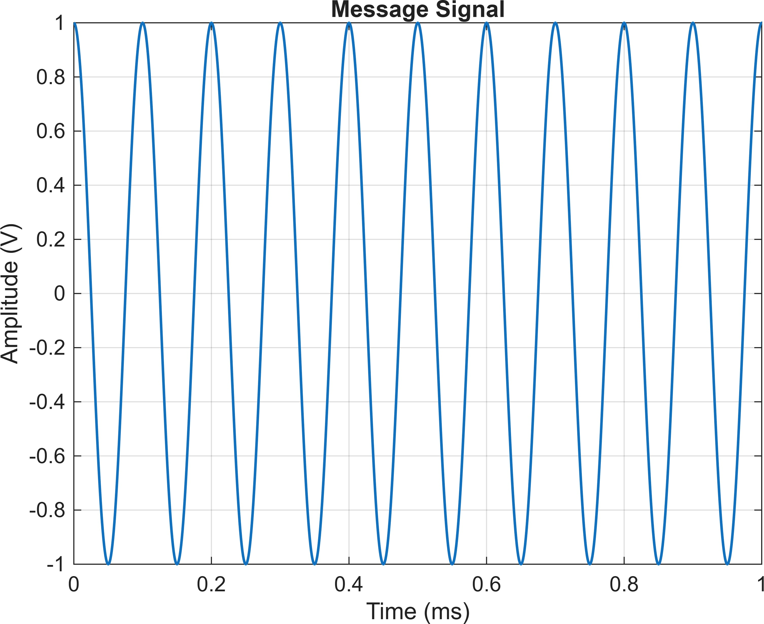

% Carrier signal figure;
plot(t*1000,carrier,'LineWidth',1);

xlabel('Time (ms)');
ylabel('Amplitude (V)'); title('Carrier Signal'); grid on;
xlim([0 0.2]);

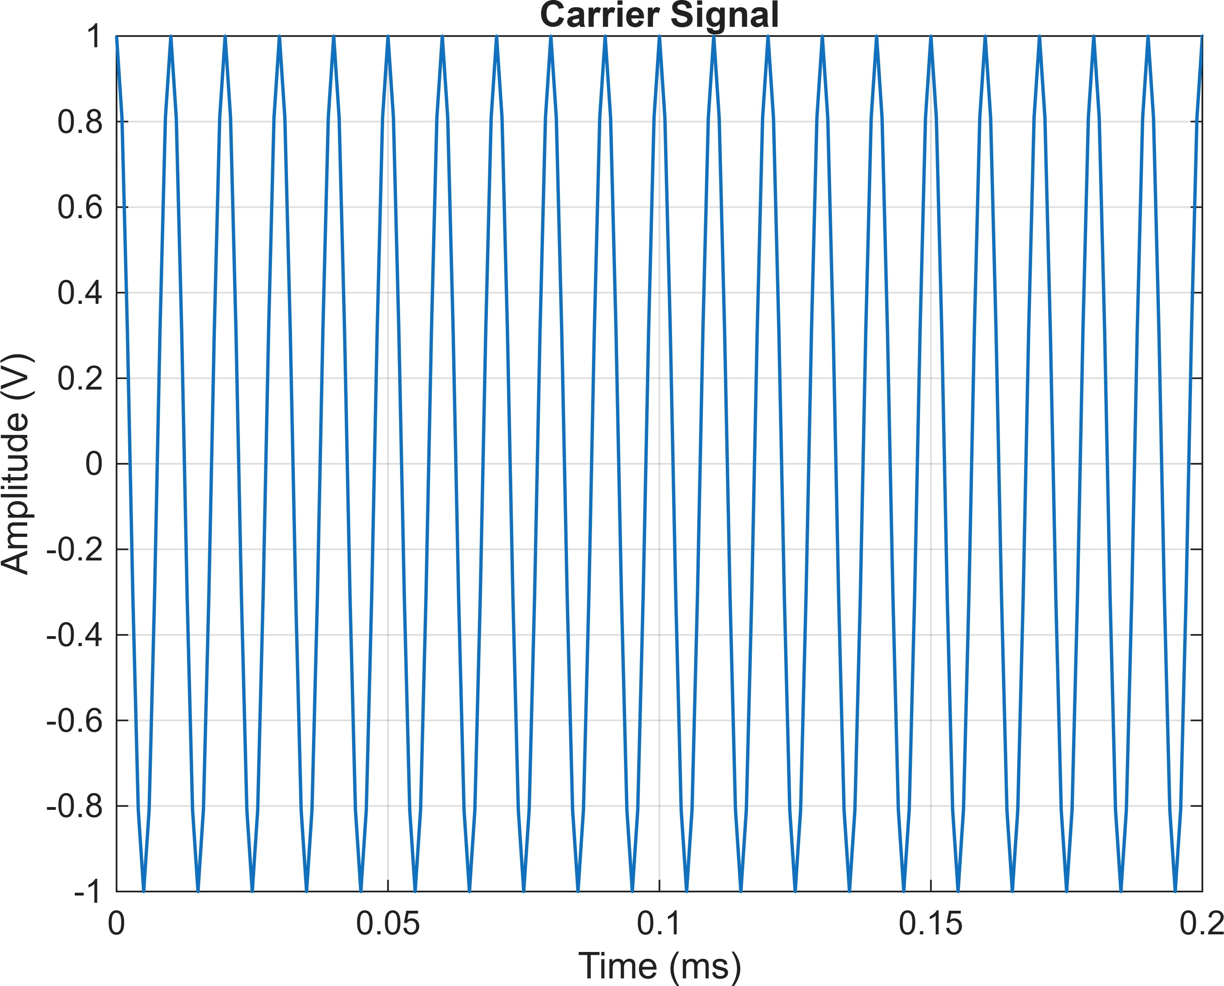

% AM signal figure;
plot(t*1000,AM_signal,'LineWidth',1);

xlabel('Time (ms)');
ylabel('Amplitude (V)');

title('Amplitude Modulated (AM) Signal'); grid on;
xlim([0 1]);

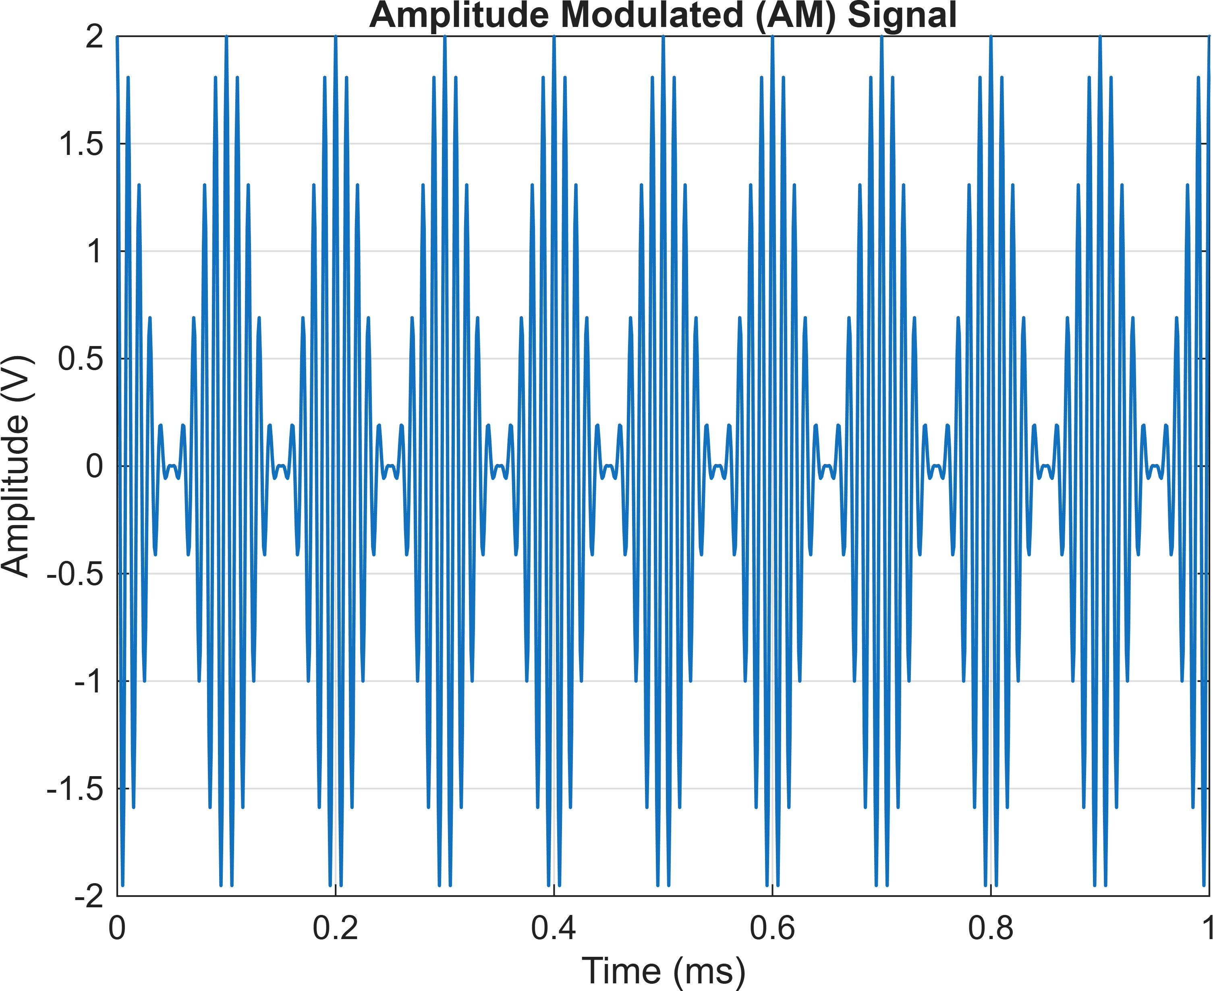

%% ============================================================
% 7. AM SPECTRUM
% ============================================================

N = length(AM_signal); AM_fft = fft(AM_signal);
AM_fft_shifted = fftshift(AM_fft); f = (-N/2:N/2-1)*(Fs/N);
AM_magnitude = abs(AM_fft_shifted)/N; figure; plot(f/1000,AM_magnitude,'LineWidth',1.2);
xlabel('Frequency (kHz)'); ylabel('Magnitude');

title('AM Frequency Spectrum'); grid on;

xlim([70 130]);
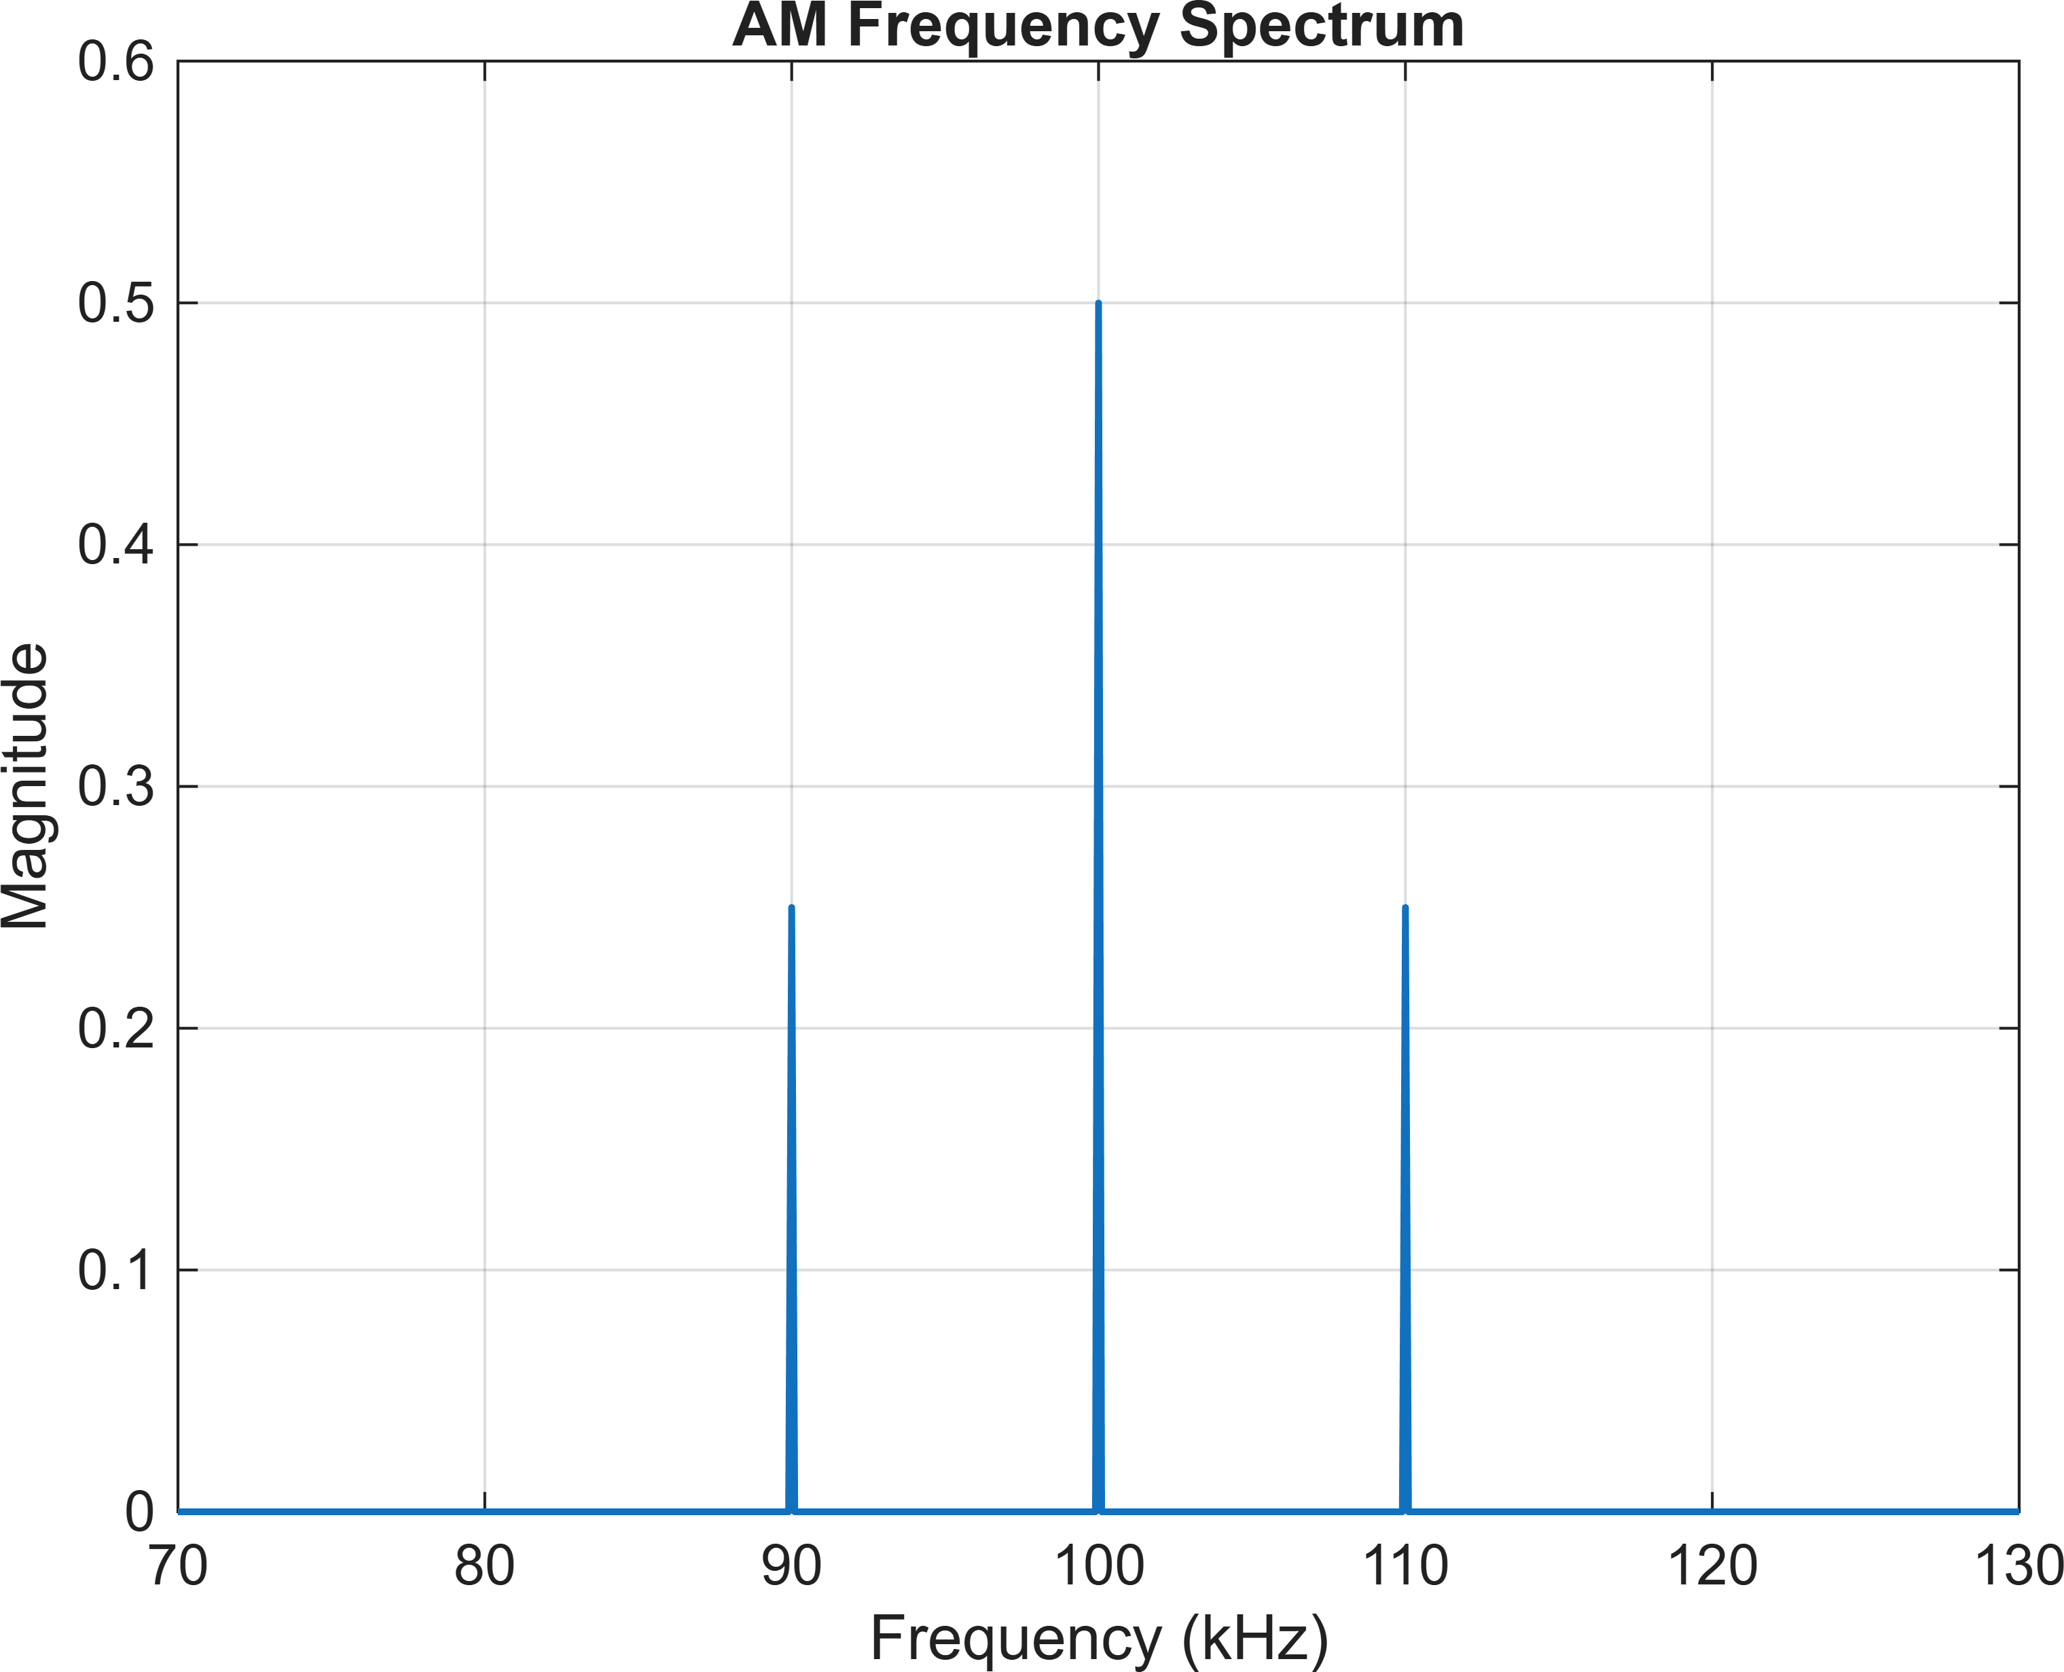

%% ============================================================
% 8. FIND USB AND LSB FREQUENCIES
% ============================================================
f_USB = fc + fm; f_LSB = fc - fm; fprintf('\n');
fprintf('Sideband Frequencies:\n');

Sideband Frequencies:

fprintf('LSB Frequency = %.2f kHz\n',f_LSB/1000);
LSB Frequency = 90.00 kHz

fprintf('Carrier Frequency = %.2f kHz\n',fc/1000);
Carrier Frequency = 100.00 kHz

fprintf('USB Frequency = %.2f kHz\n',f_USB/1000);

USB Frequency = 110.00 kHz

%% ============================================================
% 9. BANDWIDTH
% ============================================================
BW_AM = 2*fm; fprintf('\n');
fprintf('AM Bandwidth:\n');
AM Bandwidth:

fprintf('BW = 2fm = %.2f kHz\n',BW_AM/1000);
BW = 2fm = 20.00 kHz

%% ============================================================
% 10. CARRIER POWER
% ============================================================

Pc = Ac^2/(2*R);

fprintf('\n'); fprintf('Carrier Power:\n');
Carrier Power:

fprintf('Pc = %.6f W\n',Pc);
Pc = 0.010000 W

%% ============================================================
% 11. SIDEband POWER
% ============================================================

P_USB = (mu^2 * Pc)/4; P_LSB = (mu^2 * Pc)/4; P_SB_total = P_USB + P_LSB;
%% ============================================================
% 12. TOTAL AM POWER
% ============================================================

P_total = Pc + P_SB_total;

%% ============================================================
% 13. POWER EFFICIENCY
% ============================================================

efficiency = (P_SB_total/P_total)*100;

%% ============================================================
% 14. DISPLAY POWER RESULTS
% ============================================================

fprintf('\n');
fprintf('Power Calculations:\n');
Power Calculations:

fprintf('Carrier Power = %.6f W\n',Pc);

Carrier Power |  | = | 0.010000 | W
fprintf('USB | Power |  |  |  | = | %.6f | W\n',P_USB);
USB Power |  | = | 0.002500 | W
fprintf('LSB | Power |  |  |  | = | %.6f | W\n',P_LSB);
LSB Power |  | = | 0.002500 | W

fprintf('Total Sideband Power = %.6f W\n',P_SB_total);
Total Sideband Power = 0.005000 W

fprintf('Total AM Power = %.6f W\n',P_total);
Total AM Power = 0.015000 W

fprintf('Transmission Efficiency = %.2f %%\n',efficiency);
Transmission Efficiency = 33.33 %

%% ============================================================
% 15. MODULATION INDEX STUDY
% ============================================================

mu_values = 0.1:0.1:1.0;
P_USB_values = zeros(size(mu_values)); P_LSB_values = zeros(size(mu_values));

P_SB_values = zeros(size(mu_values)); P_total_values = zeros(size(mu_values)); Efficiency_values = zeros(size(mu_values)); for k = 1:length(mu_values)
m_index = mu_values(k);

P_USB_values(k) = ... (m_index^2 * Pc)/4;

P_LSB_values(k) = ... (m_index^2 * Pc)/4;

P_SB_values(k) = ...
P_USB_values(k) + P_LSB_values(k);

P_total_values(k) = ... Pc + P_SB_values(k);

Efficiency_values(k) = ... (P_SB_values(k)/P_total_values(k))*100;

end

%% ============================================================
% 16. DISPLAY MODULATION INDEX TABLE
% ============================================================

fprintf('\n'); fprintf('====================================================\n');
====================================================
fprintf(' POWER VS MODULATION INDEX\n');
POWER VS MODULATION INDEX
fprintf('====================================================\n');
====================================================

fprintf('\n'); fprintf(' Mu | USB Power | LSB Power | Total SB | Total AM\n');
Mu USB Power | LSB Power | Total SB Total | AM

fprintf(' \n');

for k = 1:length(mu_values)

fprintf(' %.1f %.6f %.6f %.6f %.6f\n', ... mu_values(k), ...
P_USB_values(k), ...
P_LSB_values(k), ...
P_SB_values(k), ... P_total_values(k));
end
0.1 | 0.000025 | 0.000025 | 0.000050 | 0.010050
0.2 | 0.000100 | 0.000100 | 0.000200 | 0.010200
0.3 | 0.000225 | 0.000225 | 0.000450 | 0.010450
0.4 | 0.000400 | 0.000400 | 0.000800 | 0.010800
0.5 | 0.000625 | 0.000625 | 0.001250 | 0.011250
0.6 | 0.000900 | 0.000900 | 0.001800 | 0.011800
0.7 | 0.001225 | 0.001225 | 0.002450 | 0.012450
0.8 | 0.001600 | 0.001600 | 0.003200 | 0.013200
0.9 | 0.002025 | 0.002025 | 0.004050 | 0.014050
1.0 | 0.002500 | 0.002500 | 0.005000 | 0.015000

fprintf(' \n');

%% ============================================================
% 17. USB POWER VS MODULATION INDEX
% ============================================================

figure;
plot(mu_values,P_USB_values,'o-','LineWidth',1.5); xlabel('Modulation Index (\mu)');
ylabel('USB Power (W)');
title('USB Power vs Modulation Index'); grid on;

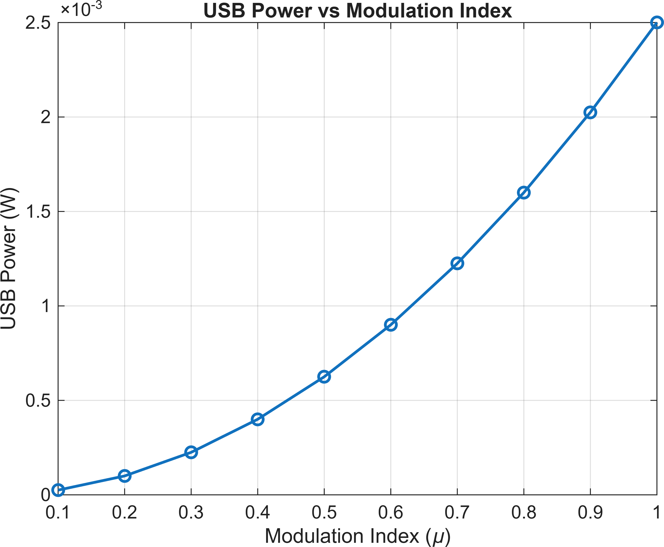

%% ============================================================
% 18. LSB POWER VS MODULATION INDEX
% ============================================================

figure;
plot(mu_values,P_LSB_values,'s-','LineWidth',1.5); xlabel('Modulation Index (\mu)');
ylabel('LSB Power (W)');
title('LSB Power vs Modulation Index'); grid on;

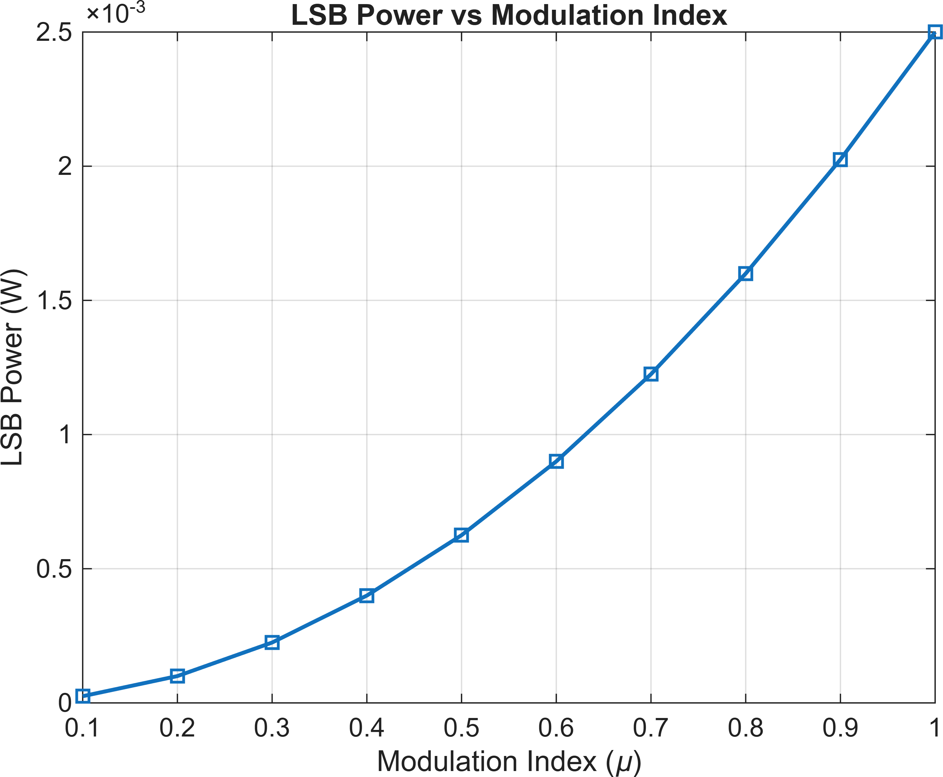

%% ============================================================
% 19. TOTAL SIDEBAND POWER VS MODULATION INDEX
% ============================================================

figure;
plot(mu_values,P_SB_values,'^-','LineWidth',1.5); xlabel('Modulation Index (\mu)');
ylabel('Total Sideband Power (W)');
title('Total Sideband Power vs Modulation Index'); grid on;

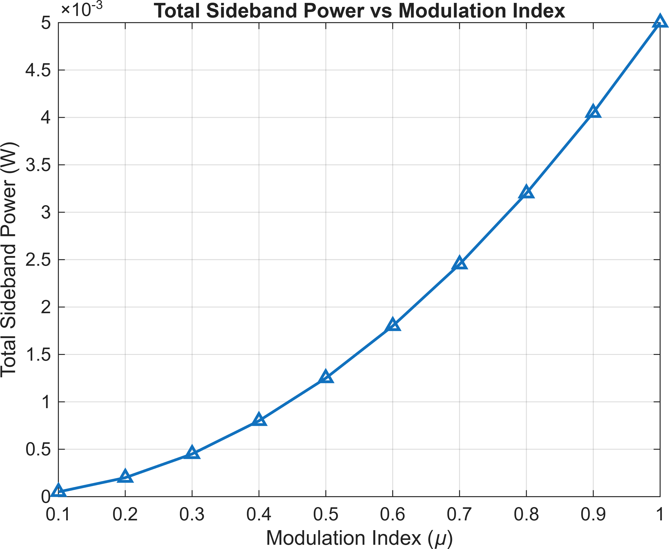

%% ============================================================
% 20. TOTAL AM POWER VS MODULATION INDEX
% ============================================================

figure;
plot(mu_values,P_total_values,'o-','LineWidth',1.5); xlabel('Modulation Index (\mu)');
ylabel('Total AM Power (W)');
title('Total AM Power vs Modulation Index'); grid on;

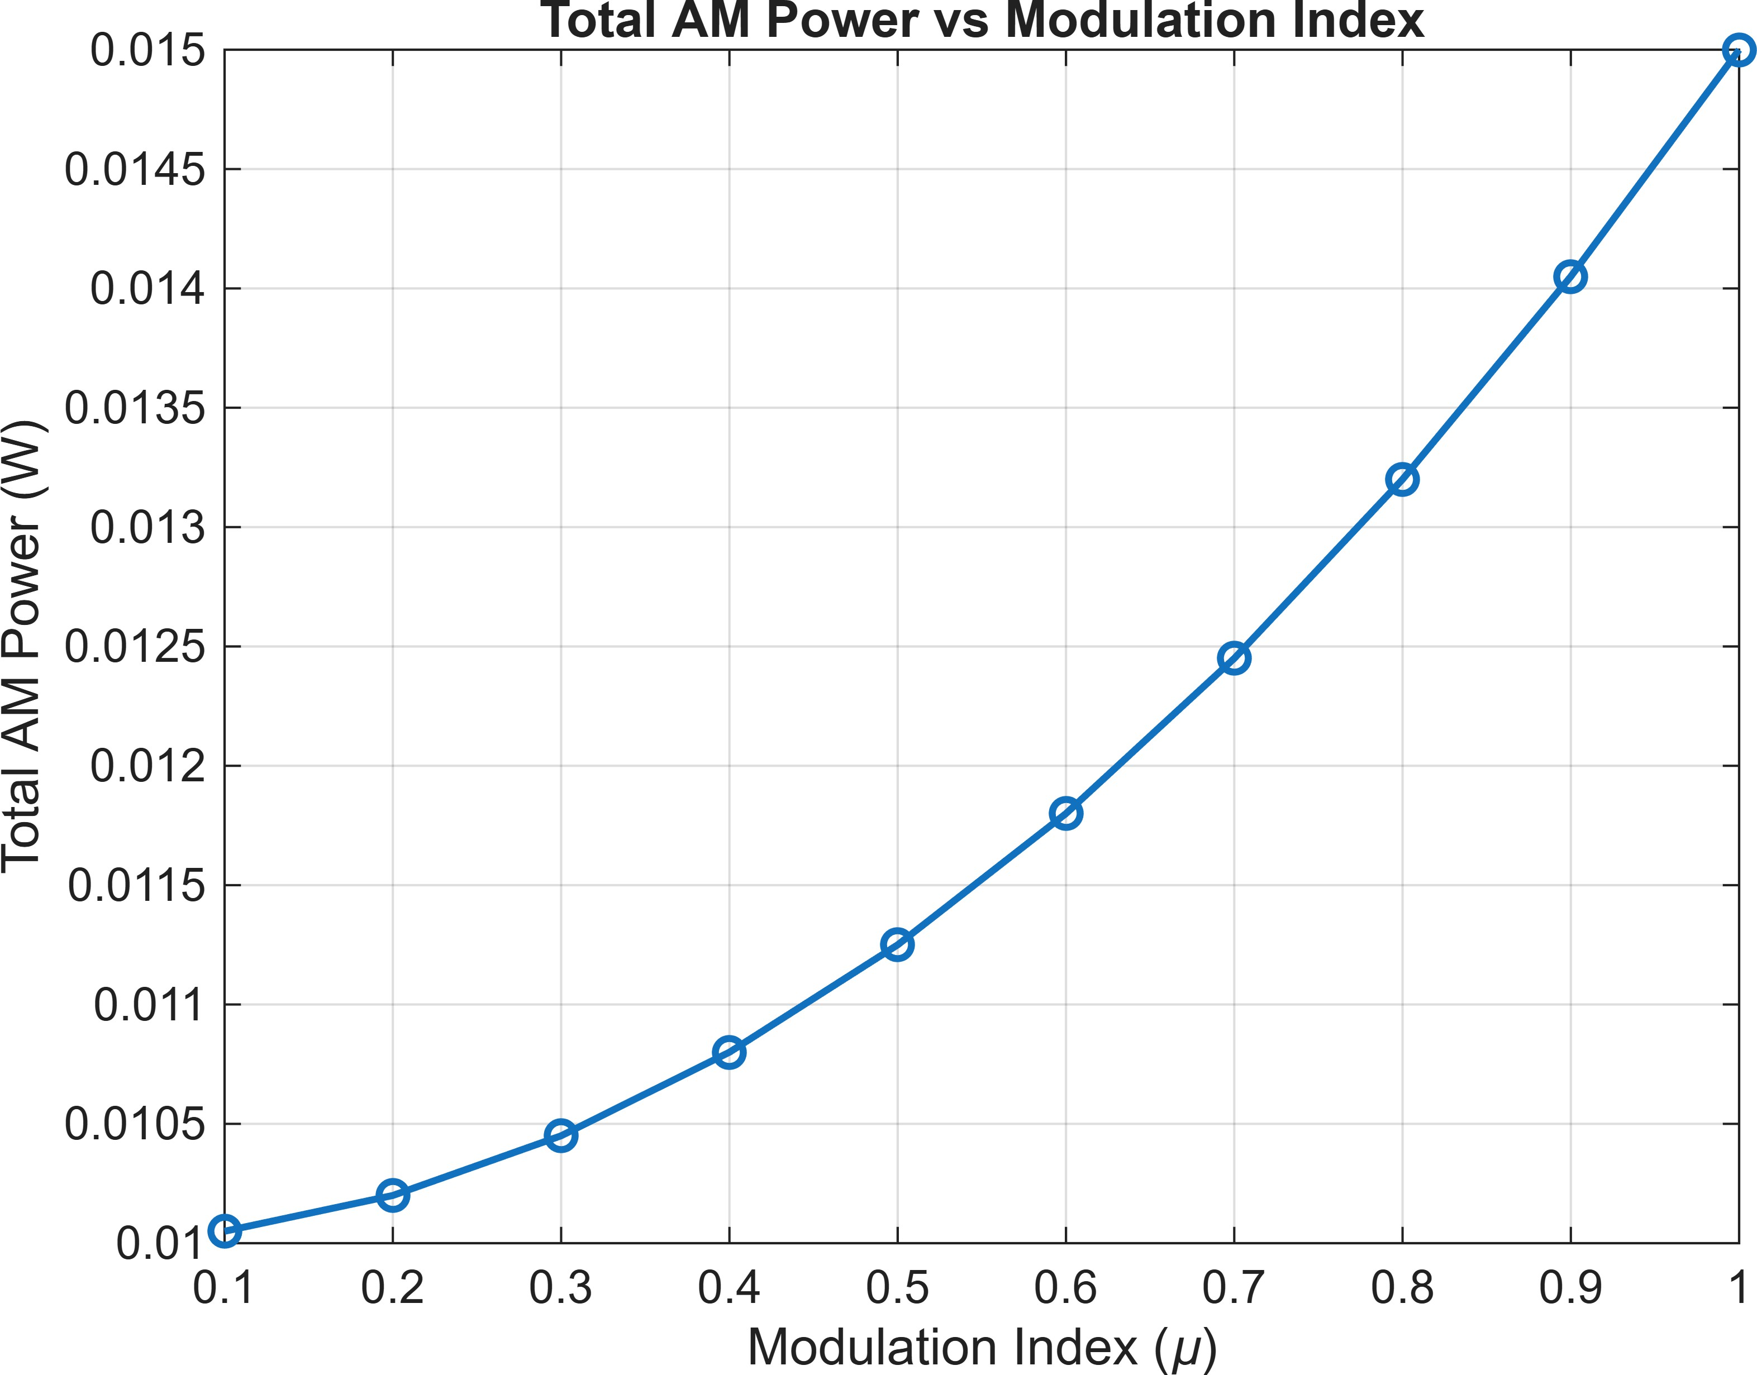

%% ============================================================
% 21. TRANSMISSION EFFICIENCY
% ============================================================

figure;
plot(mu_values,Efficiency_values,'d-','LineWidth',1.5); xlabel('Modulation Index (\mu)');
ylabel('Efficiency (%)');
title('AM Transmission Efficiency vs Modulation Index'); grid on;

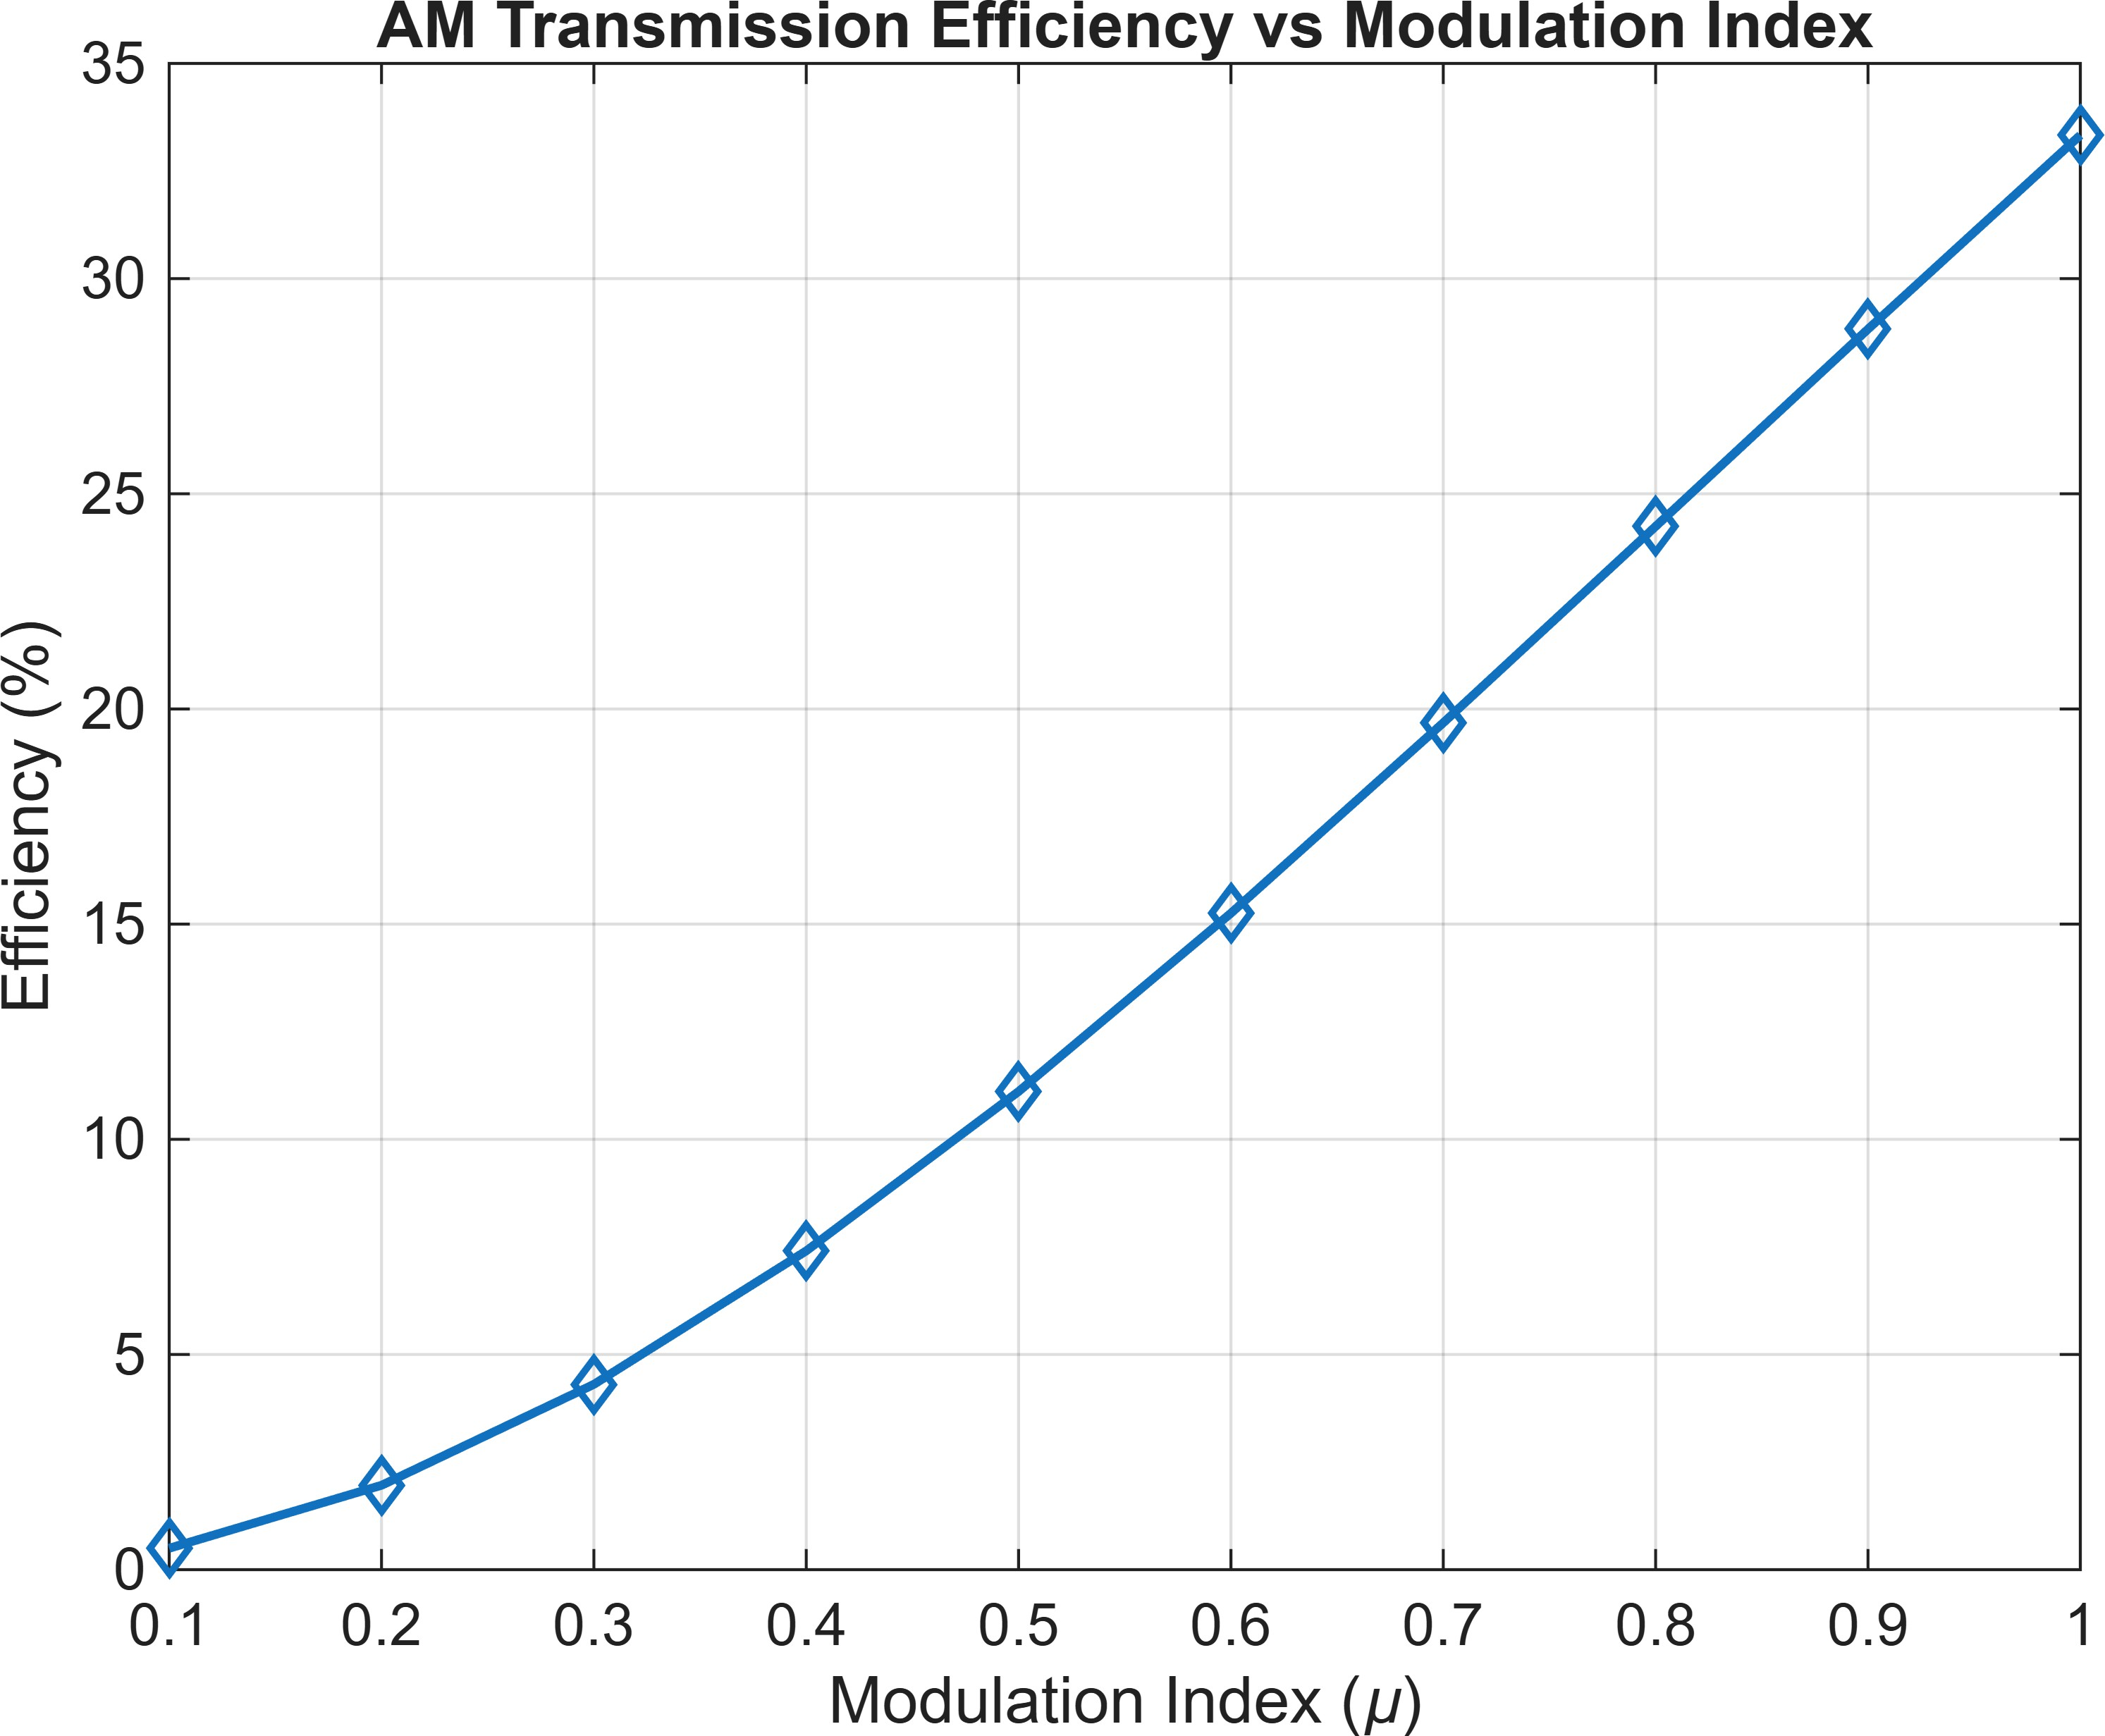

%% ============================================================
% 22. COMPARE USB AND LSB POWER
% ============================================================

figure;

plot(mu_values,P_USB_values,'o-','LineWidth',1.5); hold on;
plot(mu_values,P_LSB_values,'s-','LineWidth',1.5);

xlabel('Modulation Index (\mu)'); ylabel('Power (W)');

title('USB and LSB Power Comparison'); legend('USB Power','LSB Power');
grid on;

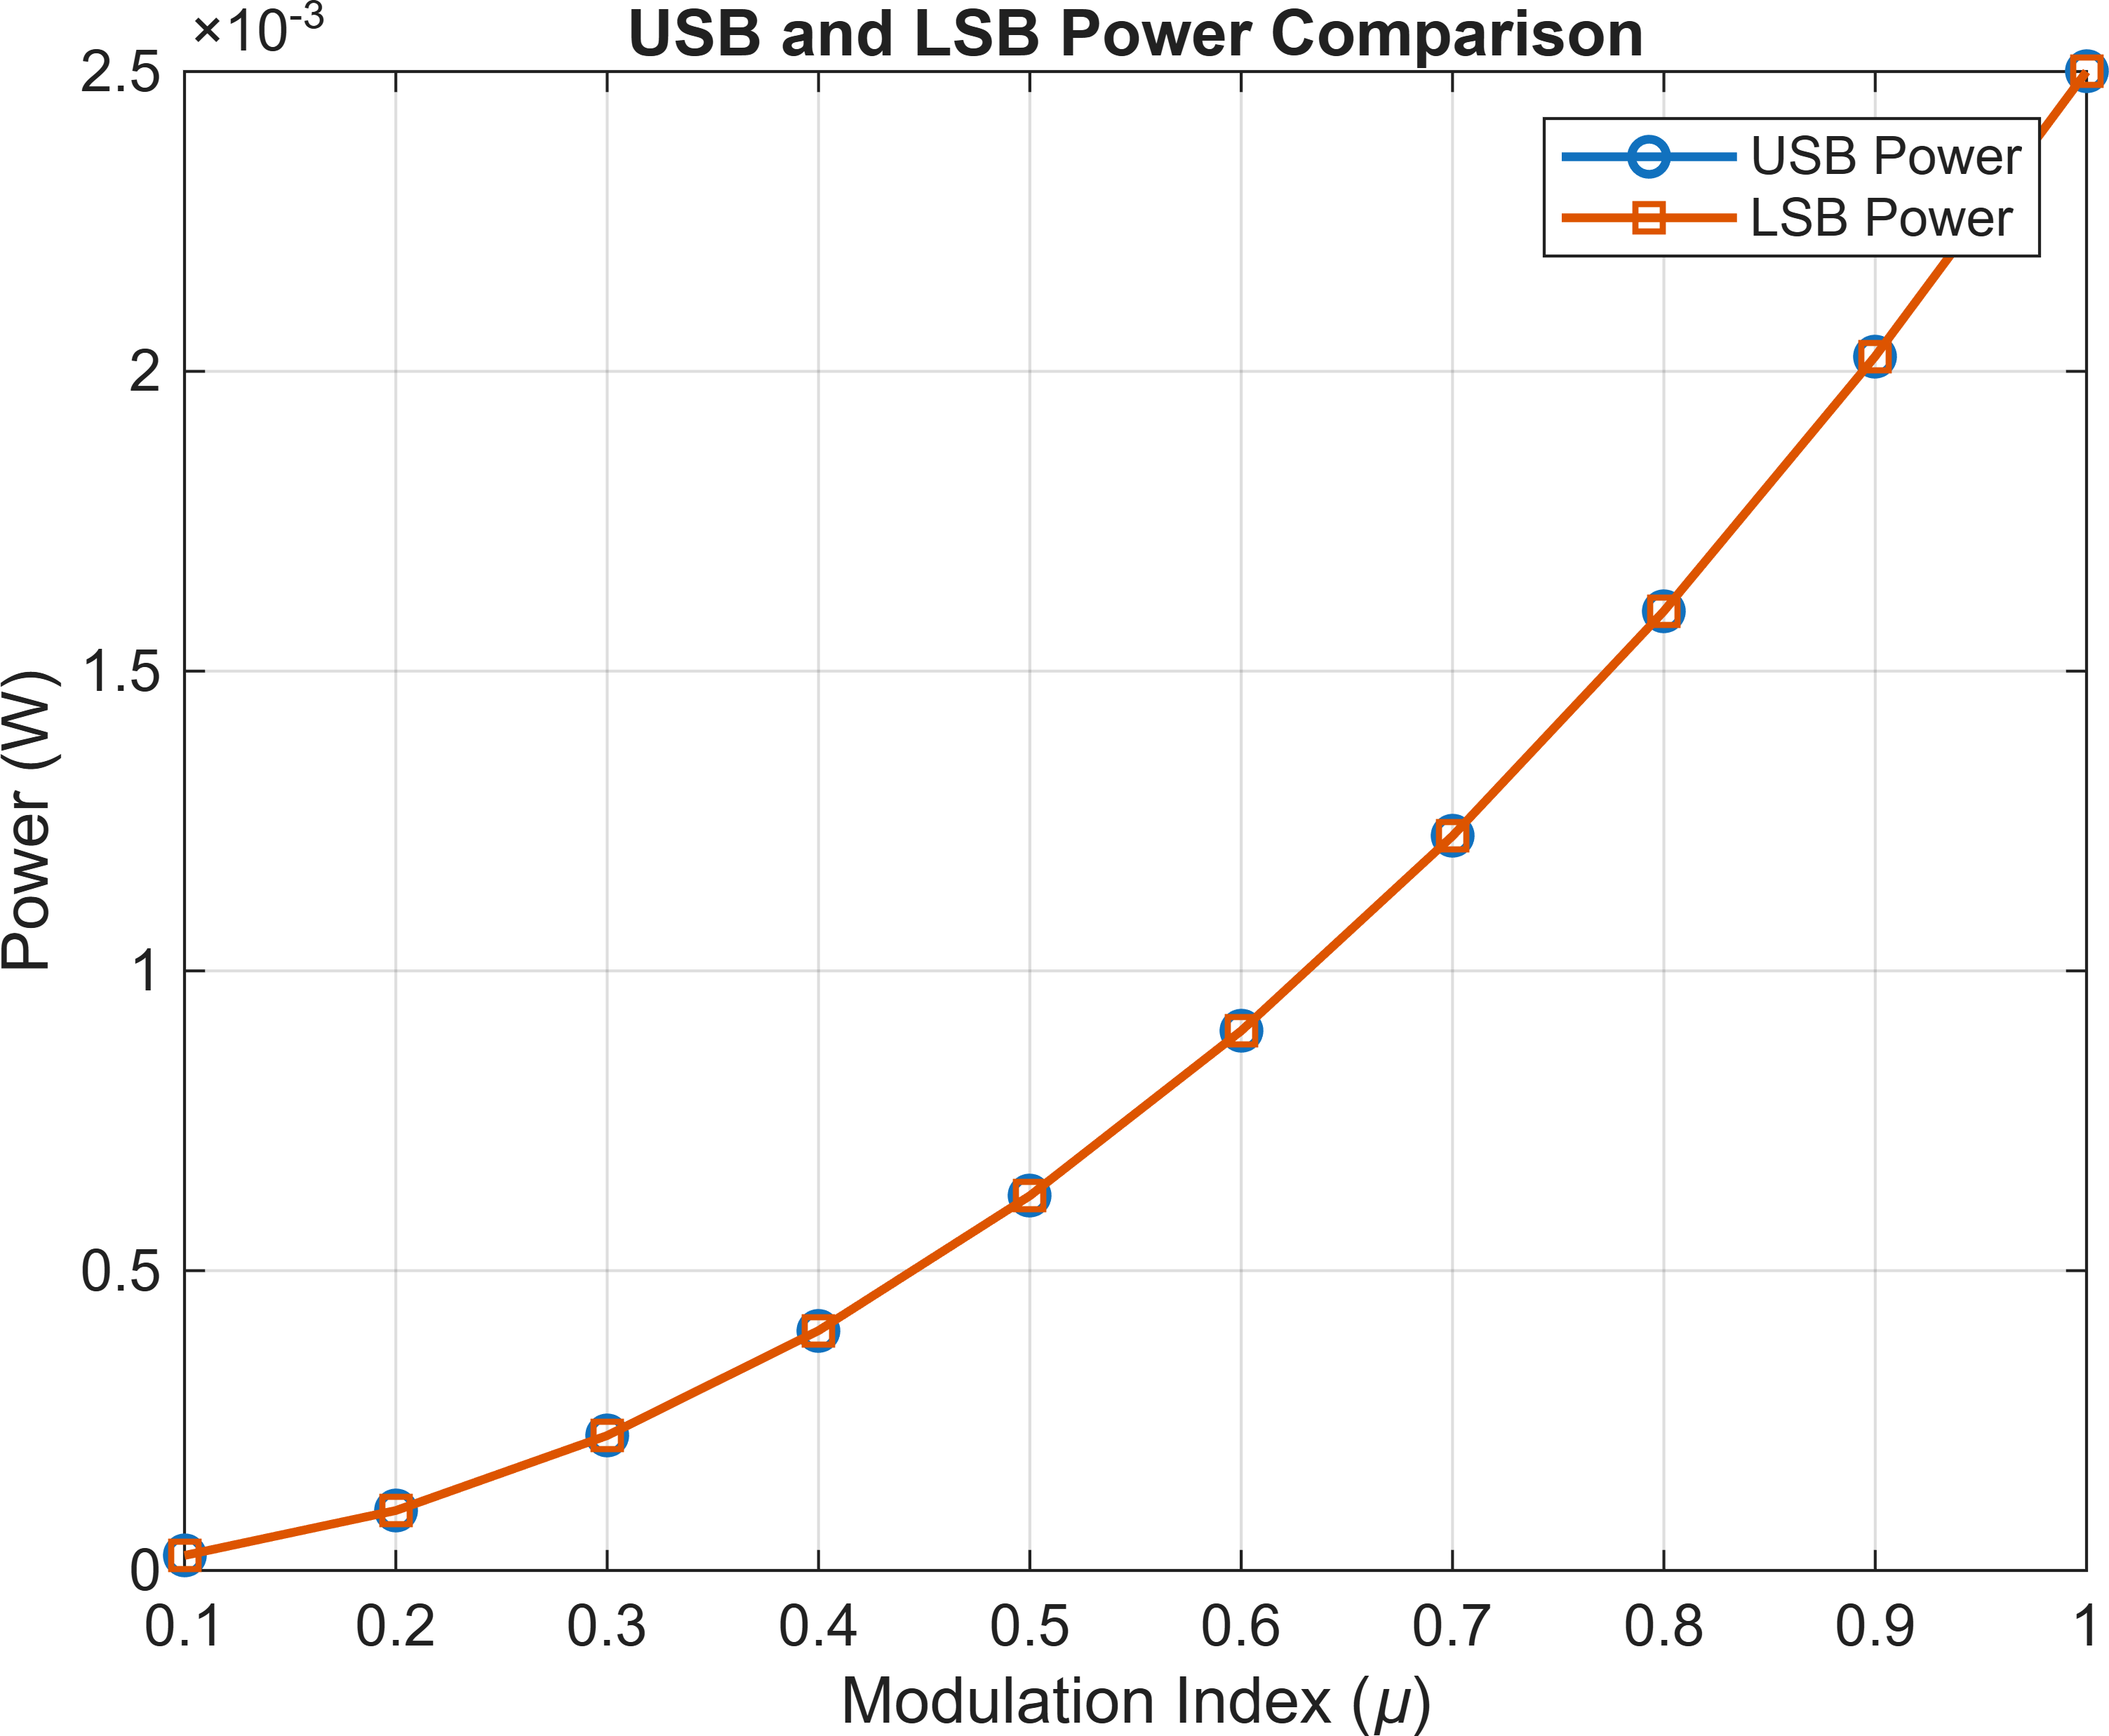

%% ============================================================
% 23. AM SPECTRUM FOR DIFFERENT MODULATION INDICES
% ============================================================ mu_plot = [0.25 0.5 0.75 1.0];
figure;
for k = 1:length(mu_plot) mu_temp = mu_plot(k); AM_temp = Ac*(1 + ...
mu_temp*cos(2*pi*fm*t)) ...
.* cos(2*pi*fc*t);
spectrum_temp = fftshift(fft(AM_temp)); magnitude_temp = ...
abs(spectrum_temp)/N; subplot(4,1,k); plot(f/1000,magnitude_temp);

xlabel('Frequency (kHz)'); ylabel('Magnitude');

title(['AM Spectrum, \mu = ', ... num2str(mu_temp)]);

grid on; xlim([70 130]);
end

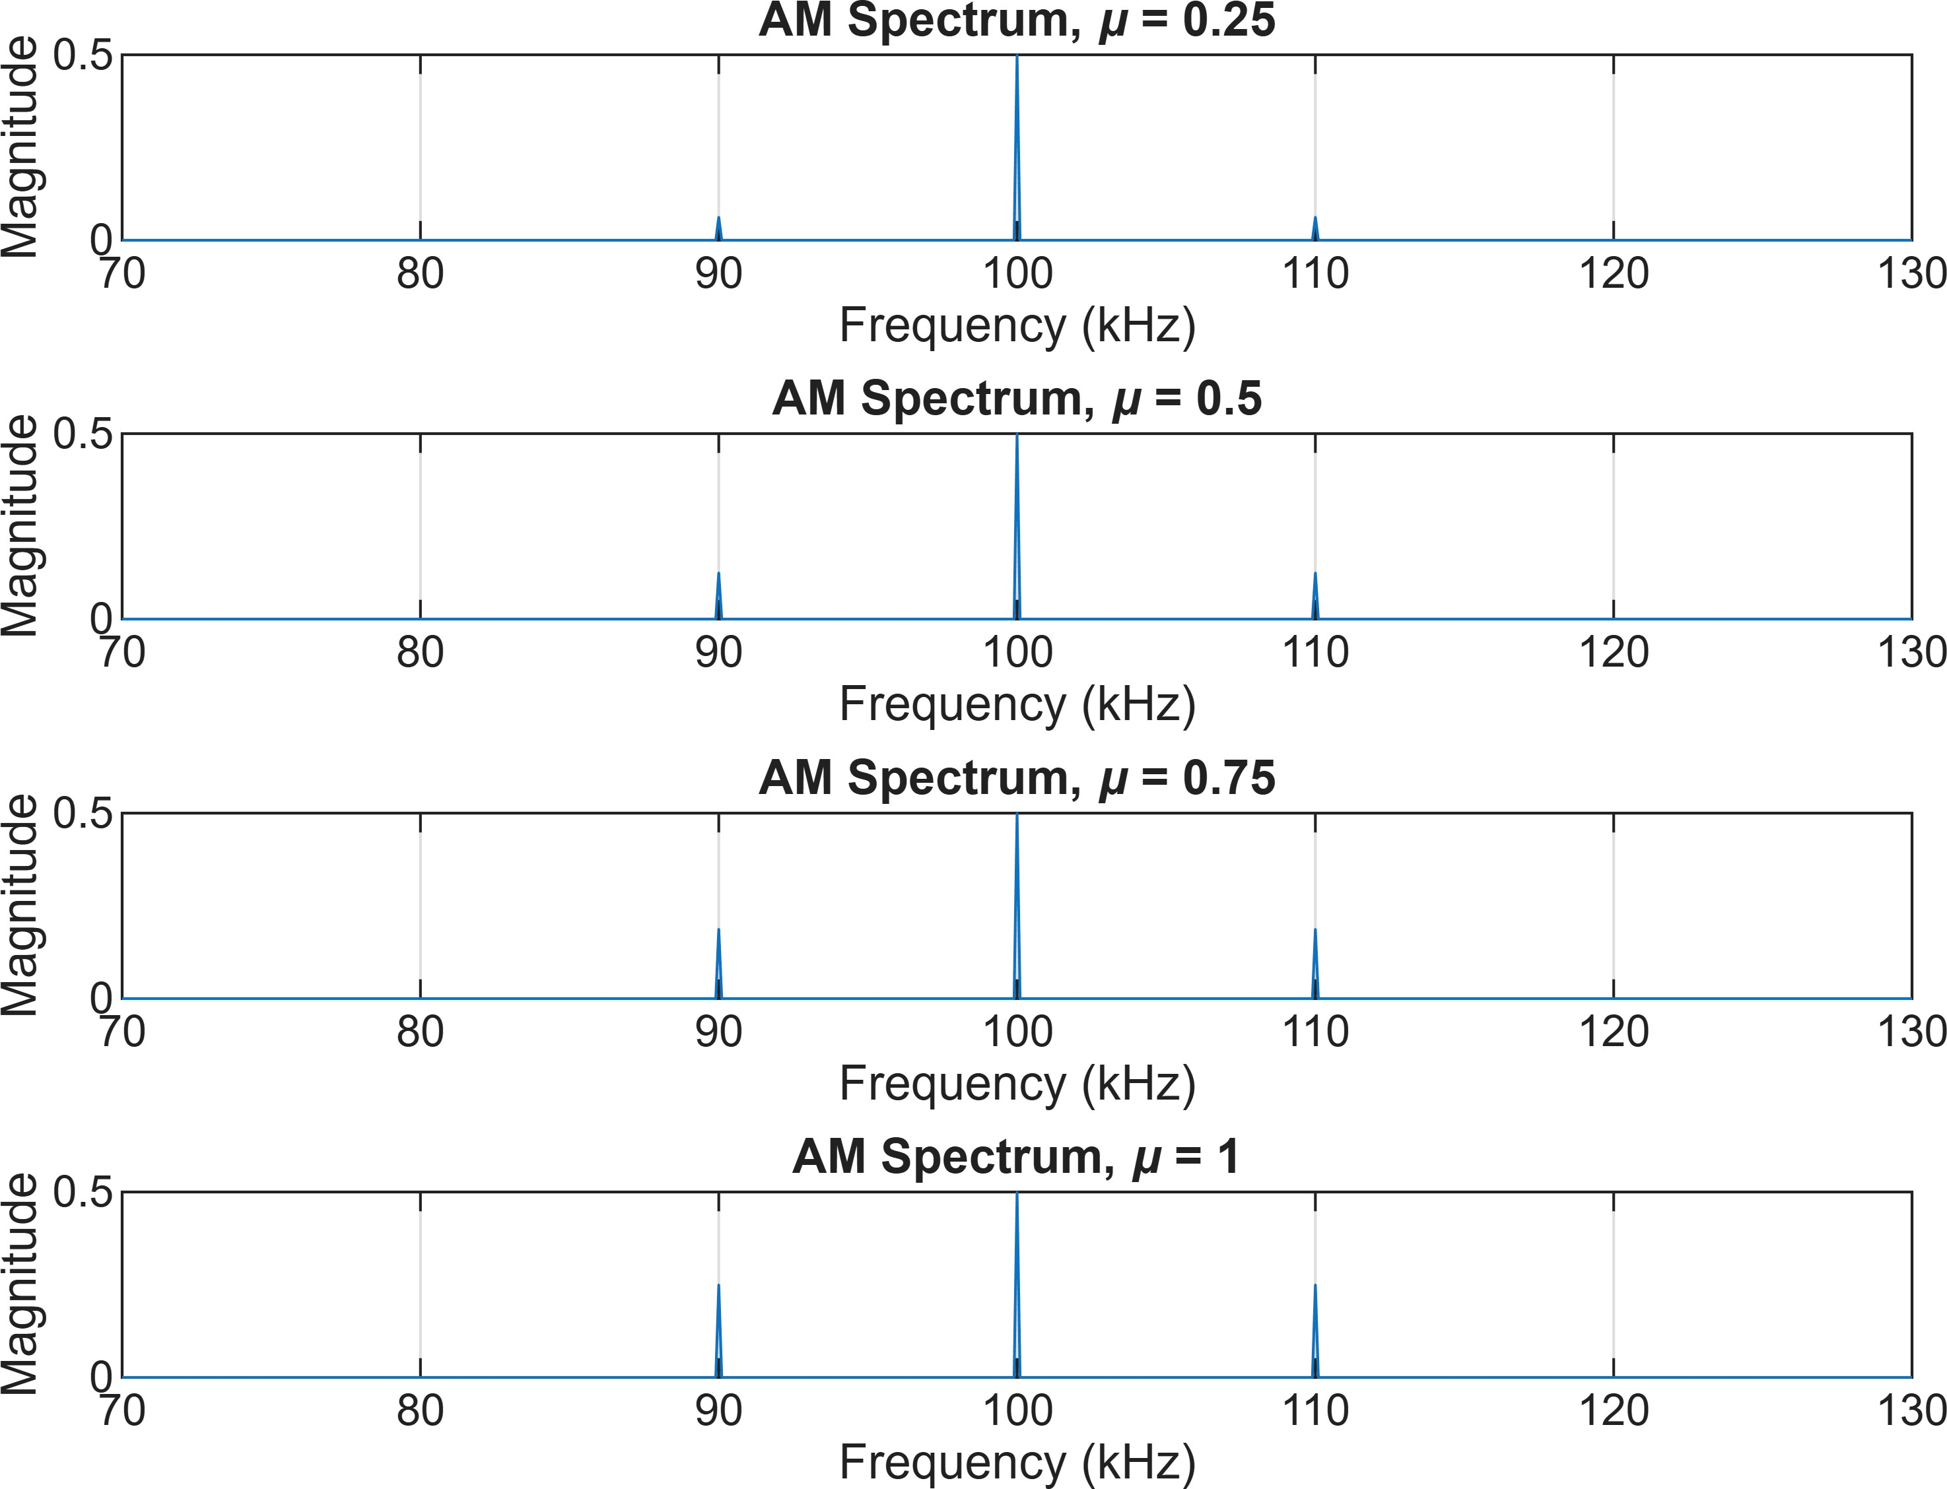

%% ============================================================
% 24. ENVELOPE OF AM SIGNAL
% ============================================================

envelope_upper = Ac*(1 + mu*cos(2*pi*fm*t)); envelope_lower = -Ac*(1 + mu*cos(2*pi*fm*t)); figure;
plot(t*1000,AM_signal); hold on;

plot(t*1000,envelope_upper,'--','LineWidth',1.2); plot(t*1000,envelope_lower,'--','LineWidth',1.2);
xlabel('Time (ms)');
ylabel('Amplitude (V)');

title('AM Signal and Its Envelope');

legend('AM Signal','Upper Envelope','Lower Envelope'); grid on;
xlim([0 1]);
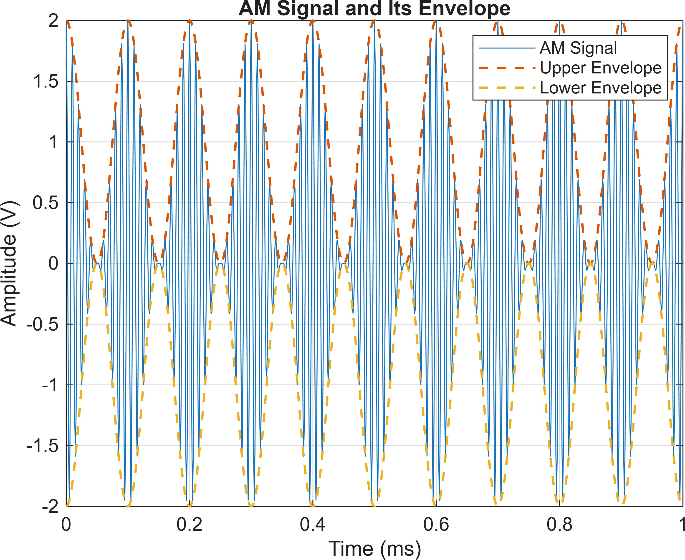

%% ============================================================
% 25. IMPORTANT RESULTS AT 100% MODULATION
% ============================================================

mu_100 = 1;
P_USB_100 = (mu_100^2 * Pc)/4; P_LSB_100 = (mu_100^2 * Pc)/4; P_SB_100 = P_USB_100 + P_LSB_100;

P_total_100 = Pc + P_SB_100; efficiency_100 = ...
(P_SB_100/P_total_100)*100;

fprintf('\n'); fprintf('====================================================\n');
====================================================
fprintf(' RESULTS FOR 100%% MODULATION\n');
RESULTS FOR 100% MODULATION
fprintf('====================================================\n');
====================================================

fprintf('Carrier Power | = | %.6f | W\n',Pc);
Carrier Power = 0.010000 W
fprintf('USB Power | = | %.6f | W\n',P_USB_100);
USB Power = 0.002500 W
fprintf('LSB Power | = | %.6f | W\n',P_LSB_100);
LSB Power = 0.002500 W

fprintf('Total Sideband Power = %.6f W\n',P_SB_100);
Total Sideband Power = 0.005000 W

fprintf('Total AM Power = %.6f W\n',P_total_100);
Total AM Power = 0.015000 W

fprintf('Transmission Efficiency = %.2f %%\n',efficiency_100);
Transmission Efficiency = 33.33 %

fprintf('====================================================\n');
====================================================

%% ============================================================

% 26. FINAL CONCLUSION
% ============================================================

fprintf('\n'); fprintf('CONCLUSION:\n');
CONCLUSION:

fprintf(['1. USB frequency = fc + fm.\n']);
- USB frequency = fc + fm.

fprintf(['2. LSB frequency = fc - fm.\n']);
- LSB frequency = fc - fm.

fprintf(['3. AM bandwidth = 2fm.\n']);
- AM bandwidth = 2fm.

fprintf(['4. Sideband power increases with mu^2.\n']);
- Sideband power increases with mu^2.

fprintf(['5. At 100%% modulation, total sideband power = Pc/2.\n']);
- At 100% modulation, total sideband power = Pc/2.

fprintf(['6. At 100%% modulation, total AM power = 1.5Pc.\n']);
- At 100% modulation, total AM power = 1.5Pc.

fprintf(['7. Maximum theoretical AM efficiency = 33.33%%.\n']);
- Maximum theoretical AM efficiency = 33.33%.

fprintf('\n====================================================\n');
====================================================
fprintf(' SIMULATION COMPLETED\n');
SIMULATION COMPLETED
fprintf('====================================================\n');
====================================================

